Shana Park HOA Board Meeting Approved Minutes: July 19, 2022
Location/Time: Arlene’s home 7:00 P.M.

Board Members attending: Arlene McMahon, Steve Fanis, Warren Devine, Roman Glova, Josh Hizon,
Bob McNally, John Sladek, Nancy Sladek. Absent: Fran Feil.
Arlene called meeting to order at 7:00 P.M.

President Report: Arlene stated that Cynthia Haunshell no longer lives in SP. Motion made, seconded, and passed to remove Cynthia from BOD.
Arlene will attend a meeting at Thurston County Courthouse regarding 2023 Shana Ct property in foreclosure with delinquent dues.

Secretary Report: Nancy stated that May 10, 2022 BOD Meeting notes e-mailed in July were not complete. She read revised notes including missing items. Revised notes approved. Nancy will e-mail copies of revised notes to all BOD members. Roman will post to website.

Treasurer Report:
- Arlene reviewed May and June Budget Reports. She did not have hard copies. She said there had been limited activity in both months. BOD members to review reports e-mailed on July 19, 2022 and vote to approve by e-mail.
- John to assume treasurer duties beginning August 1 2022. Arlene will coordinate meeting at bank with Pat Schell and John.

Website Report: Arlene has been working with Roman to update website. Roman will e-mail Alter Tract requests and Title requests to all BOD members.

Smith Lake: Warren updated BOD:
- Smith Lake is very quiet. Warren and neighbor remain alert for any new activity.
- Warren remains in contact with City of Olympia Planning.
- Olympia to update Comprehensive Pan by 2025. Current CP Transportation Grid shows Normandy extending north to 45th Avenue.
- Nancy suggested and Warren agreed to start drafting a response recommending that Normandy not be extended. John offered to help.

Old Business:
- 2022 Dues Increase: After extended discussion, Arlene, Josh, and Steve will develop a letter/ballot. They will complete draft by August 17, 2022.
- Lot 98 GB: Bob will get a complete bid from Jake’s Tree Service for cutting down to stump and removal of trees previously specified. He will send the written estimate to all board members. JTS preliminary estimate is $1500.
- There was some discussion of November 15, 2021 letter to McNally’s concerning possible reimbursement for SPHA’s expenses at Lot 98. Arlene read letter’s final sentence. Bob again threatened a lawsuit. No final decision made.

New Business:
- Lot 82 Fence: Arlene had an Alter Tract. There was some discussion. Immediately after meeting, Arlene, Steve, Josh, John, Nancy, Warren, and Roman went to Lot 82. Owner was present. After observing Owner’s fence staking, BOD unanimously approved proposed fence location.
- Garage Sale: SP will have a Community Garage Sale on August 12-13, 2022, 9:00 A.M. to 4:00 P.M. Roman will post on website. Bob will put announcements on mailboxes.
- Lot 131: A Tree fell in GB adjacent to this home during June. Arlene and Josh will observe and contact Matt B Tree Service as needed.

Next Meeting: August 9th at 7:00 PM. Location: Arlene’s home.

Adjourn: Meeting adjourned at 8:15 P.M.

Respectfully submitted,

Nancy Sladek

Shana Park Homeowners Association
 |  | Thursday 6/2/2022
 |  | By: Arlene McMahon
Assets
Category | as of 5/31/2022 | Previous EOM
Innovator Checking | $ 15,500.88 | $ 15,929.72
Legal/GB Maintenance | $ 1,492.06 | $ 1,491.99
Contingency Savings | $ 10,092.94 | $ 10,092.51
Front Sign Savings | $ 965.34 | $ 965.29
Total | $ 28,051.22 | $ 28,479.51
Expense Budget - 2022
Category | Budget 2022 | Actual Spent | Difference
Utilities | $ 5,100.00 | $ 2,144.24 | $ 2,955.76
Legal | $ - |  | $ -
Greenbelt Maintenance | $ 15,000.00 | $ 1,113.95 | $ 13,886.05
License | $ 10.00 | $ 20.00 | $ (10.00)
Insurance | $ 2,100.00 |  | $ 2,100.00
Website | $ 50.00 |  | $ 50.00
Mailings | $ 300.00 |  | $ 300.00
Front Sign | $ 100.00 | $ 100.00 | $ -
Administration | $ 200.00 | $ 191.98 | $ 8.02
Meeting Rooms | $ 50.00 | $ 10.00 | $ 40.00
Total | $ 22,910.00 | $ 3,580.17 | $ 19,329.83
Transaction - 2022
Date | Description | Category | Amount
5/21/2022 | PSE | Utilities | -$428.84
5/31/2022 | Interest Savings | Savings | $0.43
5/31/2022 | Interest Front Sign | front sign | $0.05
5/31/2022 | Interest Greenbelt/Legal | Greenbelt | $0.07
Total Deposit |  |  | $ -
Total Interest |  |  | $ 0.55
Total Expenses |  |  | $ 428.84

 |  | Checking | Legal/GB | Savings | Front Sign | Total
April | Balance Check | $15,929.72 | $1,491.99 | $10,092.51 | $965.29 | $28,479.51
 | Deposit | $0.00 | $0.07 | $0.43 | $0.05
 | Withdrawal | -$428.84
May | Balance Check | $15,500.88 | $1,492.06 | $10,092.94 | $965.34 | $28,051.22

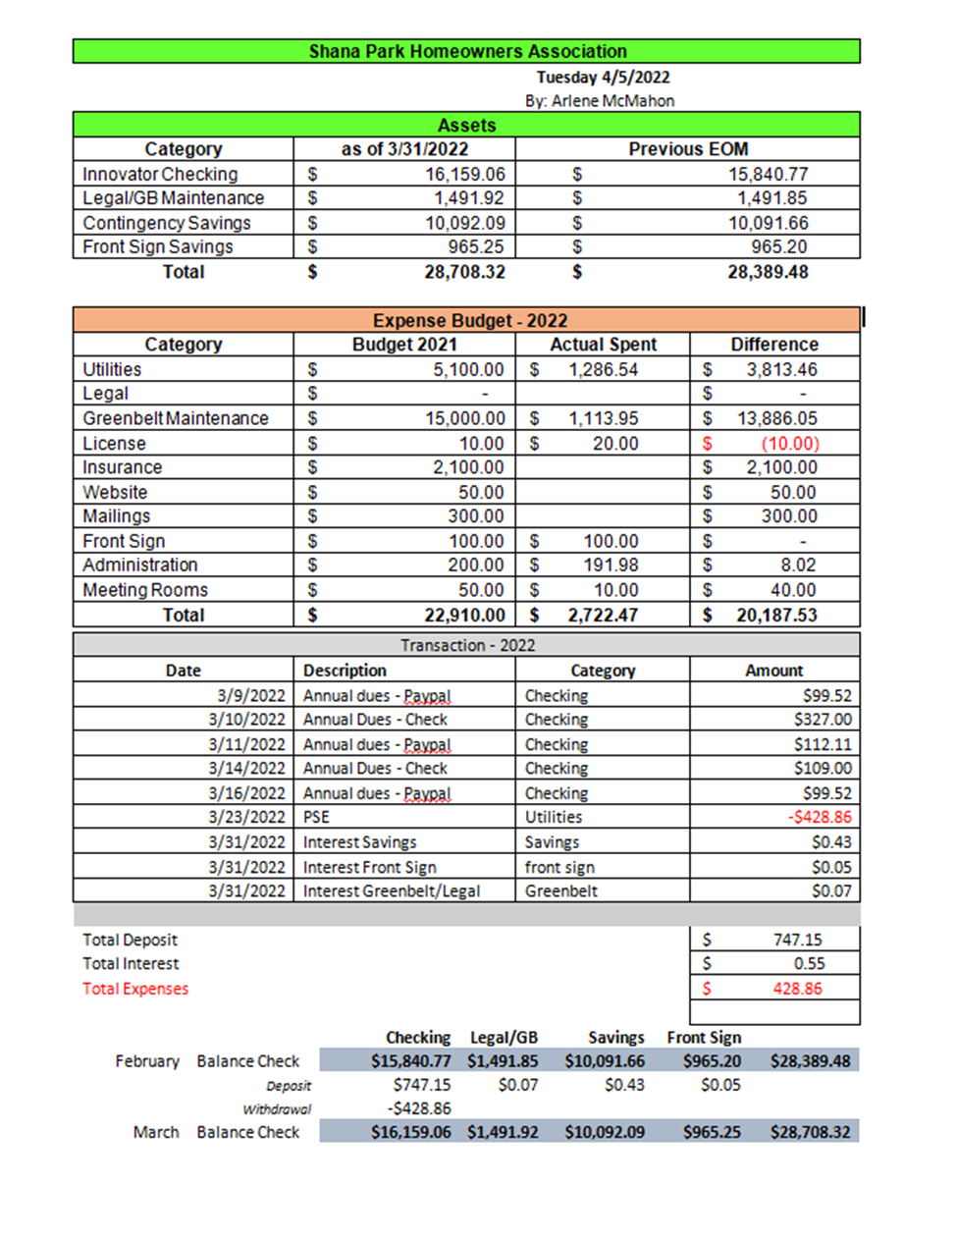
Shana Park Homeowners Association
 |  | Monday 7/11/2022
 |  | By: Arlene McMahon
Assets
Category | as of 6/30/2022 | Previous EOM
Innovator Checking | $ 15,072.40 | $ 15,500.88
Legal/GB Maintenance | $ 1,492.13 | $ 1,492.06
Contingency Savings | $ 10,093.36 | $ 10,092.94
Front Sign Savings | $ 965.38 | $ 965.34
Total | $ 27,623.27 | $ 28,051.22
Expense Budget - 2022
Category | Budget 2022 | Actual Spent | Difference
Utilities | $ 5,100.00 | $ 2,572.72 | $ 2,527.28
Legal | $ - |  | $ -
Greenbelt Maintenance | $ 15,000.00 | $ 1,113.95 | $ 13,886.05
License | $ 10.00 | $ 20.00 | $ (10.00)
Insurance | $ 2,100.00 |  | $ 2,100.00
Website | $ 50.00 |  | $ 50.00
Mailings | $ 300.00 |  | $ 300.00
Front Sign | $ 100.00 | $ 100.00 | $ -
Administration | $ 200.00 | $ 191.98 | $ 8.02
Meeting Rooms | $ 50.00 | $ 10.00 | $ 40.00
Total | $ 22,910.00 | $ 4,008.65 | $ 18,901.35
Transaction - 2022
Date | Description | Category | Amount
6/23/2022 | PSE | Utilities | -$428.48
6/30/2022 | Interest Savings | Savings | $0.42
6/30/2022 | Interest Front Sign | front sign | $0.04
6/30/2022 | Interest Greenbelt/Legal | Greenbelt | $0.07
Total Deposit |  |  | $ -
Total Interest |  |  | $ 0.53
Total Expenses |  |  | $ 428.48

 |  | Checking | LG/GB | Sav | Front Sav
May | Balance Check | $15,500.88 | $1,492.06 | $10,092.94 | $965.34 | $28,051.22
 | Deposit | $0.00 | $0.07 | $0.42 | $0.04
 | Withdrawal | -$428.48
June | Balance Check | $15,072.40 | $1,492.13 | $10,093.36 | $965.38 | $27,623.27

